SCHOOL MANAGEMENT SYSTEM
08
10
2019
A PROJECT IN MICROSOFT VISUAL BASIC
DEVLOPED BY
PRASHANT KUMAR JHA , ROLL NO-37824, BCA (III) YEAR ,CONTACT NO -8271690291, EMAIL ID –PK695036@gmail.com
[a microsoft visual basic project]

INTRODUCTION

Visual Basic is an interesting topic, which has different types. It has all the methods have their won features with each having merits and demerits which help in data processing. The topic includes their architecture representing the elements involved in it and their action is also specified.

Visual Basic 6.0 allows creating object-oriented applications. Visual Basic 6.0 profoundly concentrates on the Internet development features, Active X technology, enhanced controls, enhanced features of existing control, client/server, new language features development, data access, a few design enhancement etc.,

Relational databases are logical collection of inter-related data in tabular form relational databases have always been core to any management system. Its relevance is profound and hence the need to incorporate new functionalities, utilities becomes important. These are currently the predominant choice in storing financial records manufacturing and logistical information, personnel data and much more.
Relational databases are used in huge management systems like Post Office, Banking, Railway, Defence Logistics. Databases pertaining to Educational Institutions and other large collection of related data.
Relational databases have largely replaced hierarchical databases and network databases because they are easy to understand and use even though they are much less efficient. They have been however challenged by Object Databases and XML databases.
The three leading commercial relational database vendors are Oracle, Microsoft, and IBM.The three leading open Source implementations are MySQL,PostgreSQL, and SQLite.
The softwar components used in our project are as under:
- Microsoft Visual Basic 6.0
- Microsoft access database

OVERVIEW

A “SCHOOL MANAGEMENT SYSTEM’’ is a computerized
School management system. This management system has been developed to form whole management system including student, fee , attendance, addmision, mark, and Complains etc. This system also keeps the records of hardware assets besides software of this organization. The proposed system will keep a track of student, fee, mark, Accounts and generation of report regarding the present status. This project has GUI based software that will help in storing, updating and retrieving the information through various user-friendly menu-driven modules.

INTRODUCTION
The title of the project is “School Management system”. This project will handle whole the activities of the school. SMS has most of the facilities that a modern school requires to computerize its day-to-day jobs. It provides facilities to keep the records of student, fees, teaching and non-teaching staff with all their required details along with all required transaction handling. It has facilities to generate various types of reports, which are required by the management during normal business operations to operate the business effectively.

OBJECTIVES OF THE PROJECT

This project is based on the RDBMS technology; the main objective of this project is to computerize the manual system & reduce the time consumption. In other words we can say that our project has the following objectives:-
• Make all the system computerize
• Reduce time consumption
• Reduce error scope
• All system managements are automated
• Centralized database management
• Easy operations for operator of the system
• No paper work requirement
.

- Keeping explicit details about the patient’s diseases, diagnosis and management for comprehensive research.

- Keeping the records of salary structure of the employees of Hospital by billing
approach.

E-R DIAGRAM

CONVERTING ER DIAGRAM INTO TABLES

- Converting strong entity types

    - Each single valued attribute becomes a column
    - Derived attributes are ignored
    - Composite attributes are represented by components
    - Each entity type becomes a table
    - Multi-valued attributes are represented by a separate table
    - Key attributes of the entity type is the Primary Key

REG NO
NAME
D_O_B
PHN_NO
FATHERS_NAME
CLASS
STUDENT
LEAVING DATE

GENDER GGGGGGGGGGGENSER

ADDMISION DATE

- Converting weak entity types
- Converting relationships
Relationships are based on cardinalities and degree of the relation
- Binary n:1
IS APPOINTED
STUDENT
TEACHER

so from this relation 1:n two separate tables will be formed named as doctor and patient and they will be joined by a foreign key dept_id.

- Binary 1:1
TRANSACTS
STUDENT
FEE
1
1

- Binary m:n

IS APPOINTED
STUDENT
TEACHER
M
N

TABLE STRUCTURES

The structure of all tables included in the project is as under:-

1.STUDENT
Name Null? Type
----------------------------------------- -------- ----------------------------
*REG NO NOT NULL NUMBER(10)
NAME NOT NULL VARCHAR2(20)
D_O_B NOT NULL DATE
CLASS NOT NULL VARCHAR2(10)
FATHERS_NAME NOT NULL VARCHAR2(20)
PHN_NO NOT NULL NUMBER(11)
GENDER NOT NULL VARCHAR2(5)
ADDMISION DATE NOT NULL NUMBER(10)
SCHOOL LEVING DATE NOT NULL NUMBER(10)
SPORT ACTIVITES NOT NULL VARCHAR(10)
CONSTRAINTS:
SQL> select column_name,constraint_name,position from User_cons_columns WHERE TABLE_NAME='STUDENT';
COLUMN_NAME
----------------------------------------------------------------------------------------------------
CONSTRAINT_NAME POSITION
------------------------------ ----------
REG NO
PATPK 1
DEPT_ID
PATFK 1

2.MARK DETAILS
Name Null? Type
----------------------------------------- -------- ----------------------------
REG NO NOT NULL NUMBER(5)
CLASS NOT NULL NUMBER(5)
NAME NOT NULL VARCHAR2(25)
HINDI NOT NULL NUMBER(11)
ENGLISH NOT NULL NUMBER(11)
MATH NOT NULL NUMBER(11)
SCIENCE NOT NULL NUMBER(11)
SOC SCIENCE NOT NULL NUMBER(10)
TOTAL NOT NULL NUMBER(10)
AVG NOT NULL NUMBER(11)
DEVISION NOT NULL NUMBER(11)

CONSTRAINTS:
SQL> select column_name,constraint_name,position from User_cons_columns WHERE TABLE_NAME='MARK_DETAILS';
COLUMN_NAME
---------------------------------------------------------------------------------------------------
CONSTRAINT_NAME POSITION
------------------------------ ----------
REG_NO
NAME 1

CLASS
MARK 1

3 .FEE DETAILS
Name Null? Type
----------------------------------------- -------- ----------------------------
REG_NO NOT NULL VARCHAR2(20)
NAME NOT NULL VARCHAR2(20)
DAY NOT NULL NUMBER(11)
MONTH NOT NULL NUMBER(11)
YEAR NOT NULL NUMBER(11)
FEE PAID NOT NULL NUMBER(10)
REASON NOT NULL NUMBER(10)

CONSTRAINTS:
SQL> select column_name,constraint_name,position from User_cons_columns WHERE TABLE_NAME='FEE';
COLUMN_NAME
-------------------------------------------------------------------------------------------------
CONSTRAINT_NAME POSITION
------------------------------ ----------
REG_NO
NAME 1
FEE

- ATTENDANCE

Name Null? Type
----------------------------------------- -------- ----------------------------
REG_NO NOT NULL NUMBER(10)
NAME NOT NULL VARCHAR(20)
DAY NOT NULL NUMBER(11)
MONTH NOT NULL VARCHAR2(20)
YEAR NOT NULL VARCHAR2(10)
MORNING NOT NULL VARCHAR2(10)
AFTERNOON NOT NULL VARCHAR2(10)

CONSTRAINTS:
SQL> select column_name,constraint_name,position from User_cons_columns WHERE TABLE_NAME”ATTENDANCE”';
COLUMN_NAME
-------------------------------------------------------------------------------------------------------
CONSTRAINT_NAME POSITION
------------------------------ ----------
REG_NO
ATTENDANCE 1

NORMALISATION

Normalisation is a method for organizing data elements in a database into tables.
It keeps track to keep the database less vulnerable to some types of logical inconsistencies and anomalies.Tablescan be normalized to varying degrees like first,second,BCNF.Greater the degree of normalization more is the protected from inconsistencies and anomalies.The tables may be normalized under the following guideline:

- 1NF
DEFINITION:
A relation schema is in 1NF if all of its attributes are:
- Single valued
- Restricted to assuming atomic values
- Functionally dependent on the primary key
All tables follows the above conditions and rules ,so they are in 1NF.All attributes are single valued.

- 2NF

DEFINITION:
A relational table is said to be in second normal form 2NF if it is in 1NF and every non-key attribute is fully functionally dependent upon primary key.
The criteria for second normale form(2NF) are:

- The table must be in !NF.
- Every non-key attributes of the table must be dependent upon the entire primary key.
- In “STUDENT”,”TEACHER”,”STAF”, tables all the attributes are totally dependent on the dept_id.
- In “FEE” table all attributes are dependent on bill_no.
- So all tables are in 2 NF

- 3NF
DEFINITION:
- A relation is in 3NF if and only if,it is in 2NF and there are no transitive functional dependencies.
- Transitive functional dependencies arise.
- When one non-key attribute is functionally dependent on another non-key attribute.
- Functional Dependency:non-key attribute>non-key attribute.
- When there is redundancy in the database.

“Schedule” table is in 3NF because all the attributes are primary key.
By definition transitive functional dependency can only occur if there is more than one non-key field,so we can say that a relation in 2NF with zero or one non-key field must automatically be in 3NF.All tables are in 3NF too.

CODING START
FORM1-LOGIN PAGE
Private Sub Command1_Click()
Dim username As String
Dim password As String
username = "admin"
password = "admin"
If Trim(LCase(Text1.Text)) = Trim(LCase("admin")) And Trim(LCase(Text2.Text)) = Trim(LCase("admin")) Then
MsgBox "login sucessful"
main.Show
c = 0
Else
MsgBox "sorry......login faield......try again......"
c = c + 1
End If
If c = 3 Then
MsgBox "account is blocked"
End If
End Sub
Private Sub Command2_Click()
Text1.Text = " "
Text2.Text = " "
If Text1.Text = " " Then
MsgBox ("enter user name")
If Text2.Text = " " Then
MsgBox ("enter password")
End If
End If
End Sub
Private Sub Text1_KeyUp(KeyCode As Integer, Shift As Integer)
If KeyCode = 13 Then Text2.SetFocus
End Sub
Private Sub Text2_KeyUp(KeyCode As Integer, Shift As Integer)
If KeyCode = 13 Then Command1.SetFocus
End Sub

2 MAIN FORM
Private Sub ABOUT_Click()
Form6.Show
End Sub
Private Sub ATTA_Click()
Form4.Show
End Sub
Private Sub EXIT_Click()
confirmation = MsgBox("Do you want to EXIT", vbYesNo + vbCritical, "EXIT confirmation")
If confirmation = vbYes Then
End
MsgBox "EXIT sucessfully", vbInformation, "Message"
Else
MsgBox " EXIT NOT SUCESSFULLY !!!", vbInformation, "Message"
End If
End
End Sub
Private Sub FEE_Click()
Form5.Show
End Sub
Private Sub MARK_Click()
Form3.Show
End Sub
Private Sub STU_Click()
Form2.Show
End Sub
3 STUDENT DEATAILS

Private Sub Command1_Click()
Adodc1.Recordset.MoveFirst
End Sub
Private Sub Command2_Click()
Adodc1.Recordset.MoveNext
End Sub
Private Sub Command3_Click()
Adodc1.Recordset.MovePrevious
End Sub
Private Sub Command4_Click()
Adodc1.Recordset.MoveLast
End Sub
Private Sub Command5_Click()
Adodc1.Recordset.AddNew
End Sub
Private Sub Command6_Click()
Adodc1.Recordset.Fields("REG NO") = Text1.Text
Adodc1.Recordset.Fields("NAME") = Text2.Text
Adodc1.Recordset.Fields("CLASS") = Combo1.Text
Adodc1.Recordset.Fields("GENDER") = Combo2.Text
Adodc1.Recordset.Fields("DOB") = Text4.Text
End Sub
Private Sub Command7_Click()
Text1.Text = " "
Text2.Text = " "
Text3.Text = " "
Combo1.Text = " "
Combo2.Text = " "
Text4.Text = " "
Text5.Text = " "
Text6.Text = " "
Text7.Text = " "
Text8.Text = " "
End Sub
Private Sub Command8_Click()
confirmation = MsgBox("Do you want to delete this record", vbYesNo + vbCritical, "delete record confirmation")
If confirmation = vbYes Then
Adodc1.Recordset.Delete
MsgBox "Record has been delete sucessfully", vbInformation, "Message"
Else
MsgBox " Record not delete !!!", vbInformation, "Message"
End If
Adodc1.Recordset.Delete
End Sub
Private Sub Command9_Click()
Form2.Hide
main.Show
End Sub

4 MARK DETAILS

Private Sub Command10_Click()
Text9.Text = Val(Text4.Text) + Val(Text5.Text) + Val(Text6.Text) + Val(Text7.Text) + Val(Text8.Text)
Text10.Text = Text9.Text / 5
If Text10.Text >= 60 Then
Text11.Text = "FIRST"
ElseIf Text10.Text >= 50 Then
Text11.Text = "SECOND"
ElseIf Text10.Text >= 40 Then
Text11.Text = "THIRD"
Else
Text11.Text = "BETTER LUCK NEXT TIME..........."
End If
If Val(Text4.Text And Text5.Text And Text6.Text And Text7.Text And Text8.Text) < 30 Then
Text11.Text = "BETTER LUCK NEXT TIME..."
End If
End Sub

Private Sub Command1_Click()
Adodc1.Recordset.MoveFirst
End Sub

Private Sub Command2_Click()
Adodc1.Recordset.MoveNext
End Sub

Private Sub Command3_Click()
Adodc1.Recordset.MovePrevious
End Sub

Private Sub Command4_Click()
Adodc1.Recordset.MoveLast
End Sub

Private Sub Command5_Click()
Adodc1.Recordset.AddNew
End Sub

Private Sub Command6_Click()
Adodc1.Recordset.Fields("REG NO") = Text1.Text
Adodc1.Recordset.Fields("CLASS") = Text2.Text
Adodc1.Recordset.Fields("NAME") = Text3.Text
Adodc1.Recordset.Fields("HINDI") = Text4.Text
Adodc1.Recordset.Fields("ENGLISH") = Text5.Text
Adodc1.Recordset.Fields("MATH") = Text6.Text
Adodc1.Recordset.Fields("SCIENCE") = Text7.Text
Adodc1.Recordset.Fields("SOC SCIENCE") = Text8.Text
Adodc1.Recordset.Fields("TOTAL") = Text9.Text
Adodc1.Recordset.Fields("AVG") = Text10.Text
Adodc1.Recordset.Fields("DEVESION") = Text11.Text

End Sub

Private Sub Command7_Click()
Text5.Text = " "
Text6.Text = " "
Text7.Text = " "
Text8.Text = " "
Text9.Text = " "
Text10.Text = " "
Text4.Text = " "
Text11.Text = " "
End Sub

Private Sub Command8_Click()
confirmation = MsgBox("Do you want to delete this record", vbYesNo + vbCritical, "delete record confirmation")
If confirmation = vbYes Then
Adodc1.Recordset.Delete
MsgBox "Record has been delete sucessfully", vbInformation, "Message"
Else
MsgBox " Record not delete !!!", vbInformation, "Message"
End If
Adodc1.Recordset.Delete
End Sub

Private Sub Command9_Click()
main.Show
Form3.Hide
End Sub

Private Sub Text1_KeyUp(KeyCode As Integer, Shift As Integer)
If KeyCode = 13 Then Text2.SetFocus

End Sub
Private Sub Text2_KeyUp(KeyCode As Integer, Shift As Integer)
If KeyCode = 13 Then Text3.SetFocus

End Sub
Private Sub Text3_KeyUp(KeyCode As Integer, Shift As Integer)
If KeyCode = 13 Then Text4.SetFocus

End Sub
Private Sub Text4_KeyUp(KeyCode As Integer, Shift As Integer)
If KeyCode = 13 Then Text5.SetFocus

End Sub
Private Sub Text5_KeyUp(KeyCode As Integer, Shift As Integer)
If KeyCode = 13 Then Text6.SetFocus

End Sub
Private Sub Text6_KeyUp(KeyCode As Integer, Shift As Integer)
If KeyCode = 13 Then Text7.SetFocus

End Sub
Private Sub Text7_KeyUp(KeyCode As Integer, Shift As Integer)
If KeyCode = 13 Then Text8.SetFocus

End Sub
Private Sub Text8_KeyUp(KeyCode As Integer, Shift As Integer)
If KeyCode = 13 Then Text9.SetFocus

End Sub
Private Sub Text9_KeyUp(KeyCode As Integer, Shift As Integer)
If KeyCode = 13 Then Text10.SetFocus

End Sub
Private Sub Text10_KeyUp(KeyCode As Integer, Shift As Integer)
If KeyCode = 13 Then Text11.SetFocus

End Sub
Private Sub Text11_KeyUp(KeyCode As Integer, Shift As Integer)
If KeyCode = 13 Then Text1.SetFocus
End Sub

4 ATTENDANCE
Private Sub Command2_Click()
Adodc1.Recordset.MoveNext
End Sub
Private Sub Command3_Click()
Adodc1.Recordset.MovePrevious
End Sub
Private Sub Command4_Click()
Adodc1.Recordset.MoveLast
End Sub
Private Sub Command5_Click()
Adodc1.Recordset.AddNew
End Sub
Private Sub Command6_Click()
Adodc1.Recordset.Fields("REG NO") = Text1.Text
Adodc1.Recordset.Fields("NAME") = Text2.Text
Adodc1.Recordset.Fields("DAY") = Text3.Text
Adodc1.Recordset.Fields("MONTH") = Combo1.Text
Adodc1.Recordset.Fields("YEAR") = Text4.Text
Adodc1.Recordset.Fields("MORNING") = Text5.Text
Adodc1.Recordset.Fields("AFTERNOON") = Text6.Text
End Sub
Private Sub Command7_Click()
Text1.Text = " "
Text2.Text = " "
Text3.Text = " "
Combo1.Text = " "
Text4.Text = " "
Text5.Text = " "
Text6.Text = " "
End Sub
Private Sub Command8_Click()
confirmation = MsgBox("Do you want to delete this record", vbYesNo + vbCritical, "delete record confirmation")
If confirmation = vbYes Then
Adodc1.Recordset.Delete
MsgBox "Record has been delete sucessfully", vbInformation, "Message"
Else
MsgBox " Record not delete !!!", vbInformation, "Message"
End If
Adodc1.Recordset.Delete
End Sub

Private Sub Text1_KeyUp(KeyCode As Integer, Shift As Integer)
If KeyCode = 13 Then Text2.SetFocus
End Sub
Private Sub Text2_KeyUp(KeyCode As Integer, Shift As Integer)
If KeyCode = 13 Then Text3.SetFocus
End Sub
Private Sub Text3_KeyUp(KeyCode As Integer, Shift As Integer)
If KeyCode = 13 Then Combo1.SetFocus
End Sub
Private Sub COMBO1_KeyUp(KeyCode As Integer, Shift As Integer)
If KeyCode = 13 Then Text4.SetFocus
End Sub
Private Sub Text4_KeyUp(KeyCode As Integer, Shift As Integer)
If KeyCode = 13 Then Text5.SetFocus
End Sub
Private Sub Text5_KeyUp(KeyCode As Integer, Shift As Integer)
If KeyCode = 13 Then Text6.SetFocus
End Sub
Private Sub Text6_KeyUp(KeyCode As Integer, Shift As Integer)
If KeyCode = 13 Then Text1.SetFocus
End Sub

FEE DEATAILS
Private Sub Command1_Click()
Adodc1.Recordset.MoveFirst
End Sub
Private Sub Command2_Click()
Adodc1.Recordset.MoveNext
End Sub
Private Sub Command3_Click()
Adodc1.Recordset.MoveLast
End Sub
Private Sub Command4_Click()
Adodc1.Recordset.MovePrevious
End Sub
Private Sub Command5_Click()
Adodc1.Recordset.AddNew
End Sub
Private Sub Command6_Click()
Adodc1.Recordset.Fields("REG NO") = Text1.Text
Adodc1.Recordset.Fields("NAME") = Text2.Text
Adodc1.Recordset.Fields("DAY") = Text3.Text
Adodc1.Recordset.Fields("MONTH") = Combo1.Text
Adodc1.Recordset.Fields("YEAR") = Text5.Text
Adodc1.Recordset.Fields("FEE PAID") = Text6.Text
Adodc1.Recordset.Fields("REASON") = Text7.Text
End Sub
Private Sub Command7_Click()
confirmation = MsgBox("Do you want to delete this record", vbYesNo + vbCritical, "delete record confirmation")
If confirmation = vbYes Then
Adodc1.Recordset.Delete
MsgBox "Record has been delete sucessfully", vbInformation, "Message"
Else
MsgBox " Record not delete !!!", vbInformation, "Message"
End If
Adodc1.Recordset.Delete
End Sub
Private Sub Command()
End Sub
Private Sub Command9_Click()
main.Show
Form5.Hide
End Sub
Private Sub Command8_Click()
Text1.Text = " "
Text2.Text = " "
Text3.Text = " "
Combo1.Text = " "
Text5.Text = " "
Text6.Text = " "
Text7.Text = " "
End Sub
Private Sub Text1_KeyUp(KeyCode As Integer, Shift As Integer)
If KeyCode = 13 Then Text2.SetFocus
End Sub
Private Sub Text2_KeyUp(KeyCode As Integer, Shift As Integer)
If KeyCode = 13 Then Text3.SetFocus
End Sub
Private Sub Text3_KeyUp(KeyCode As Integer, Shift As Integer)
If KeyCode = 13 Then Combo1.SetFocus
End Sub
Private Sub Text5_KeyUp(KeyCode As Integer, Shift As Integer)
If KeyCode = 13 Then Text6.SetFocus
End Sub
Private Sub Text6_KeyUp(KeyCode As Integer, Shift As Integer)
If KeyCode = 13 Then Text7.SetFocus
End Sub
Private Sub Text7_KeyUp(KeyCode As Integer, Shift As Integer)
If KeyCode = 13 Then Text1.SetFocus
End Sub
Private Sub COMBO1_KeyUp(KeyCode As Integer, Shift As Integer)
If KeyCode = 13 Then Text5.SetFocus
End Sub
6 ABOUT
Option Explicit
' Reg Key Security Options...
Const READ_CONTROL = &H20000
Const KEY_QUERY_VALUE = &H1
Const KEY_SET_VALUE = &H2
Const KEY_CREATE_SUB_KEY = &H4
Const KEY_ENUMERATE_SUB_KEYS = &H8
Const KEY_NOTIFY = &H10
Const KEY_CREATE_LINK = &H20
Const KEY_ALL_ACCESS = KEY_QUERY_VALUE + KEY_SET_VALUE + _
KEY_CREATE_SUB_KEY + KEY_ENUMERATE_SUB_KEYS + _
KEY_NOTIFY + KEY_CREATE_LINK + READ_CONTROL

' Reg Key ROOT Types...
Const HKEY_LOCAL_MACHINE = &H80000002
Const ERROR_SUCCESS = 0
Const REG_SZ = 1 ' Unicode nul terminated string
Const REG_DWORD = 4 ' 32-bit number

Const gREGKEYSYSINFOLOC = "SOFTWARE\Microsoft\Shared Tools Location"
Const gREGVALSYSINFOLOC = "MSINFO"
Const gREGKEYSYSINFO = "SOFTWARE\Microsoft\Shared Tools\MSINFO"
Const gREGVALSYSINFO = "PATH"
Private Declare Function RegOpenKeyEx Lib "advapi32" Alias "RegOpenKeyExA" (ByVal hKey As Long, ByVal lpSubKey As String, ByVal ulOptions As Long, ByVal samDesired As Long, ByRef phkResult As Long) As Long
Private Declare Function RegQueryValueEx Lib "advapi32" Alias "RegQueryValueExA" (ByVal hKey As Long, ByVal lpValueName As String, ByVal lpReserved As Long, ByRef lpType As Long, ByVal lpData As String, ByRef lpcbData As Long) As Long
Private Declare Function RegCloseKey Lib "advapi32" (ByVal hKey As Long) As Long
Private Sub Command1_Click()
Unload Me
End Sub
Private Sub Command2_Click()
Call StartSysInfo
End Sub
Public Sub StartSysInfo()
On Error GoTo SysInfoErr
Dim rc As Long
Dim SysInfoPath As String
' Try To Get System Info Program Path\Name From Registry...
If GetKeyValue(HKEY_LOCAL_MACHINE, gREGKEYSYSINFO, gREGVALSYSINFO, SysInfoPath) Then
' Try To Get System Info Program Path Only From Registry...
ElseIf GetKeyValue(HKEY_LOCAL_MACHINE, gREGKEYSYSINFOLOC, gREGVALSYSINFOLOC, SysInfoPath) Then
' Validate Existance Of Known 32 Bit File Version
If (Dir(SysInfoPath & "\MSINFO32.EXE") <> "") Then
SysInfoPath = SysInfoPath & "\MSINFO32.EXE"
' Error - File Can Not Be Found...
Else
GoTo SysInfoErr
End If
' Error - Registry Entry Can Not Be Found...
Else
GoTo SysInfoErr
End If
Call Shell(SysInfoPath, vbNormalFocus)
Exit Sub
SysInfoErr:
MsgBox "System Information Is Unavailable At This Time", vbOKOnly
End Sub
Public Function GetKeyValue(KeyRoot As Long, KeyName As String, SubKeyRef As String, ByRef KeyVal As String) As Boolean
Dim i As Long ' Loop Counter
Dim rc As Long ' Return Code
Dim hKey As Long ' Handle To An Open Registry Key
Dim hDepth As Long '
Dim KeyValType As Long ' Data Type Of A Registry Key
Dim tmpVal As String ' Tempory Storage For A Registry Key Value
Dim KeyValSize As Long ' Size Of Registry Key Variable
'------------------------------------------------------------
' Open RegKey Under KeyRoot {HKEY_LOCAL_MACHINE...}
'------------------------------------------------------------
rc = RegOpenKeyEx(KeyRoot, KeyName, 0, KEY_ALL_ACCESS, hKey) ' Open Registry Key

If (rc <> ERROR_SUCCESS) Then GoTo GetKeyError ' Handle Error...

tmpVal = String$(1024, 0) ' Allocate Variable Space
KeyValSize = 1024 ' Mark Variable Size

'------------------------------------------------------------
' Retrieve Registry Key Value...
'------------------------------------------------------------
rc = RegQueryValueEx(hKey, SubKeyRef, 0, _
KeyValType, tmpVal, KeyValSize) ' Get/Create Key Value

If (rc <> ERROR_SUCCESS) Then GoTo GetKeyError ' Handle Errors

If (Asc(Mid(tmpVal, KeyValSize, 1)) = 0) Then ' Win95 Adds Null Terminated String...
tmpVal = Left(tmpVal, KeyValSize - 1) ' Null Found, Extract From String
Else ' WinNT Does NOT Null Terminate String...
tmpVal = Left(tmpVal, KeyValSize) ' Null Not Found, Extract String Only
End If
'------------------------------------------------------------
' Determine Key Value Type For Conversion...
'------------------------------------------------------------
Select Case KeyValType ' Search Data Types...
Case REG_SZ ' String Registry Key Data Type
KeyVal = tmpVal ' Copy String Value
Case REG_DWORD ' Double Word Registry Key Data Type
For i = Len(tmpVal) To 1 Step -1 ' Convert Each Bit
KeyVal = KeyVal + Hex(Asc(Mid(tmpVal, i, 1))) ' Build Value Char. By Char.
Next
KeyVal = Format$("&h" + KeyVal) ' Convert Double Word To String
End Select

GetKeyValue = True ' Return Success
rc = RegCloseKey(hKey) ' Close Registry Key
Exit Function ' Exit

GetKeyError: ' Cleanup After An Error Has Occured...
KeyVal = "" ' Set Return Val To Empty String
GetKeyValue = False ' Return Failure
rc = RegCloseKey(hKey) ' Close Registry Key
End Function
CODING END
SNAPSHORT
LOGIN PAGE

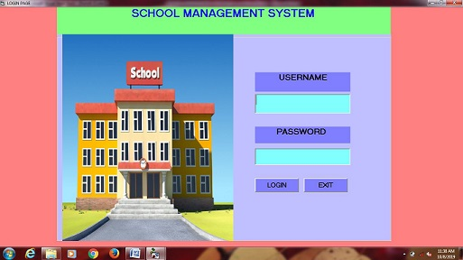

MAIN PAGE
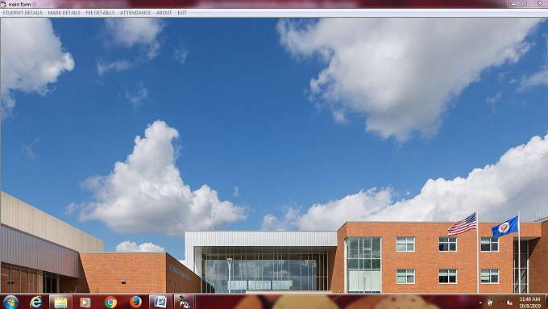

STUDENTS DETAILS
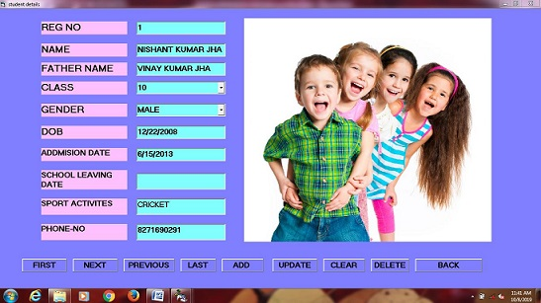

MARK DETAILS
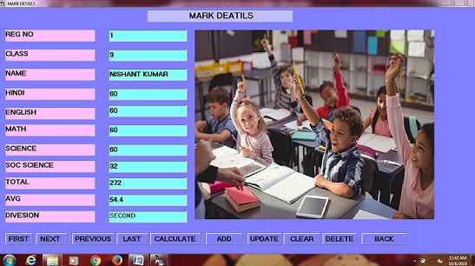

FEE DETAILS
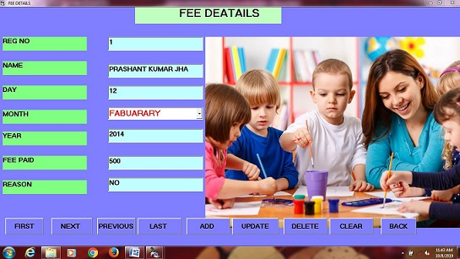

ATTENDANCE
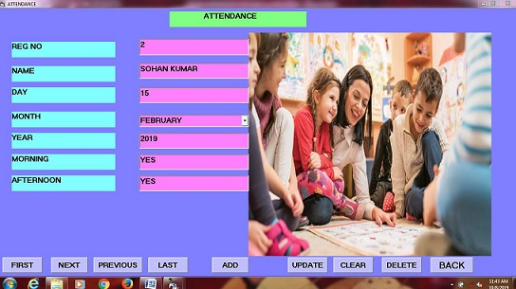
ABO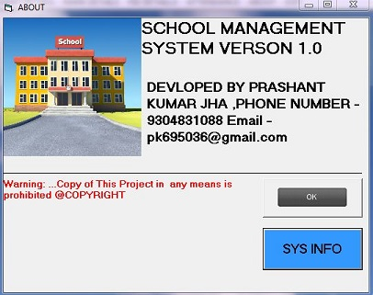

CONCLUSION

A “SCHOOL MANAGEMENT SYSTEM’’ is a computerized management system.

This management system has been developed to form whole management system including STUDENT, TEACHER (consultants), FEE, ADDMISION ,MARK, and Appointments etc. This system also keeps the records of hardware assets besides software of this organization. The proposed system will keep a track of Employees, STUDENT, TEACHER, Accounts and generation of report regarding the present status.

This project has GUI based software that will help in storing, updating and retrieving the information through various user-friendly menu-driven modules.

A computerized school management system has been developed and the system was tested with sample data.

The system results in regular timely preparations of required outputs. In comparison with manual system the benefits under a computer system are considerable in the saving of man power working hours .

Provision for addition and deletion of patients is there in the system it is possible to view that proper filling system has been adopted to slate date for future. The entire project runs on windows environments.

SCOPE OF ENHANCEMENT

The system may be further updated to handle more number of patients efficiently.

